Exercise 1: Implementing the Singleton Pattern
NAME- AKSHARA BHARGAVA
EMAIL ID-aksharabhargava6@gmail.com
Objective
Create a class that allows only one object to be created.
Step 1: Create Logger.java
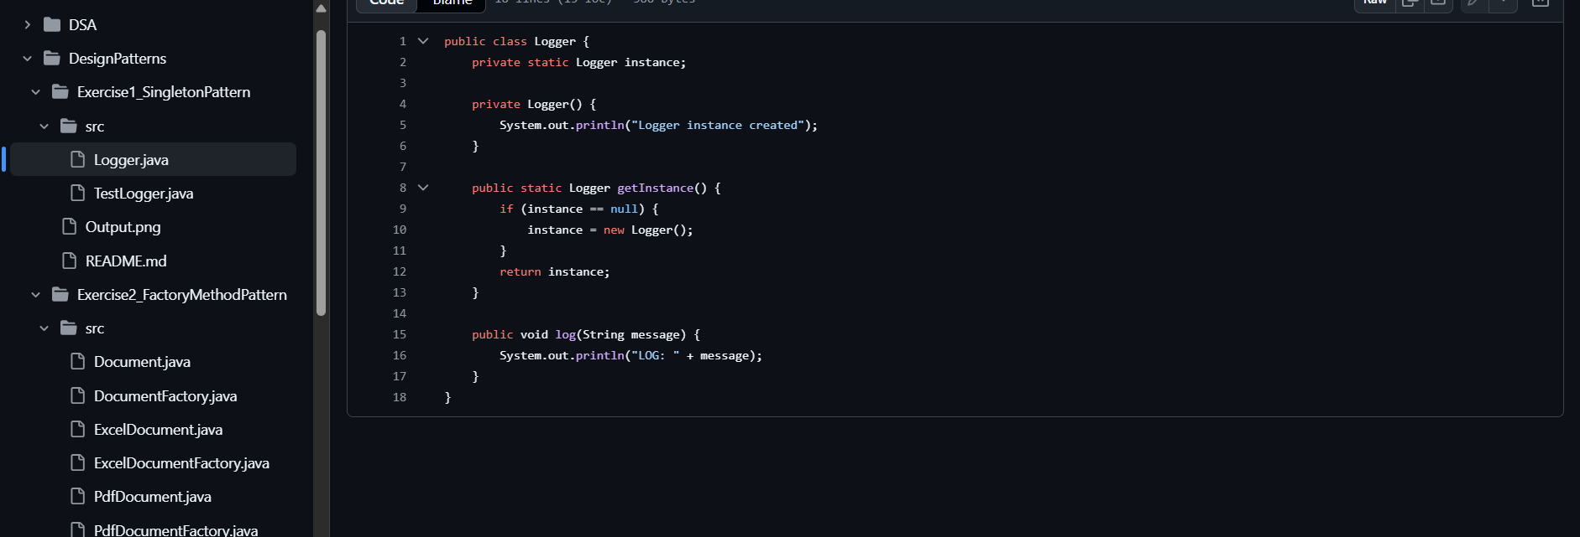
public class Logger {

private static Logger instance;

private Logger() {
System.out.println("Logger Instance Created");
}

public static Logger getInstance() {
if (instance == null) {
instance = new Logger();
}
return instance;
}

public void log(String message) {
System.out.println("LOG: " + message);
}
}
Step 2: Create Main.java
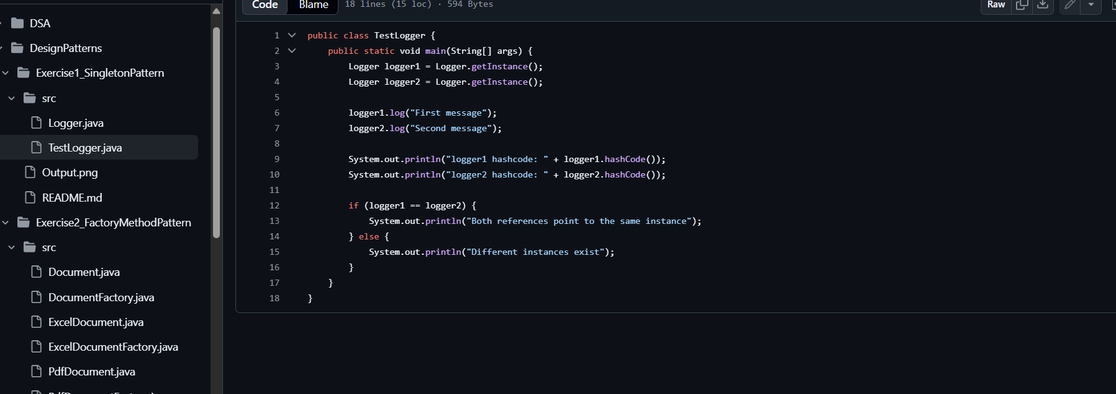
public class Main {

public static void main(String[] args) {

Logger logger1 = Logger.getInstance();
logger1.log("First Message");

Logger logger2 = Logger.getInstance();
logger2.log("Second Message");

if(logger1 == logger2){
System.out.println("Both objects are same.");
}
}
}
Output
Logger Instance Created
LOG: First Message
LOG: Second Message
Both objects are same.

Folder Structure
SingletonPattern
│
├── Logger.java
└── Main.java
Viva Questions
Q1. Why is the constructor private?
To prevent creating objects using new.
Q2. Why use Singleton?
When only one instance should exist, such as:
- Logger
- Database Connection
- Configuration Manager
- Cache
Result
Successfully implemented the Singleton Design Pattern.

The Logger object is created only once and reused throughout the application, confirming the Singleton behavior.

Exercise 2: Implementing the Factory Method Pattern
Objective
To implement the Factory Method Design Pattern in Java and understand how object creation can be delegated to factory classes.
Project Structure
FactoryMethodPattern/
│
├── Document.java
├── WordDocument.java
├── PdfDocument.java
├── ExcelDocument.java
│
├── DocumentFactory.java
├── WordFactory.java
├── PdfFactory.java
├── ExcelFactory.java
│
└── Main.java

Step 1: Create the Document Interface
Document.java
public interface Document {
void open();
}

Step 2: Create Concrete Documents
WordDocument.java
public class WordDocument implements Document {
@Override
public void open() {
System.out.println("Opening Word Document...");
}
}

PdfDocument.java
public class PdfDocument implements Document {
@Override
public void open() {
System.out.println("Opening PDF Document...");
}
}

ExcelDocument.java
public class ExcelDocument implements Document {
@Override
public void open() {
System.out.println("Opening Excel Document...");
}
}

Step 3: Create the Abstract Factory
DocumentFactory.java
public abstract class DocumentFactory {
public abstract Document createDocument();
public void openDocument() {
Document document = createDocument();
document.open();
}
}

Step 4: Create Factory Classes
WordFactory.java
public class WordFactory extends DocumentFactory {
@Override
public Document createDocument() {
return new WordDocument();
}
}

PdfFactory.java
public class PdfFactory extends DocumentFactory {
@Override
public Document createDocument() {
return new PdfDocument();
}
}

ExcelFactory.java
public class ExcelFactory extends DocumentFactory {
@Override
public Document createDocument() {
return new ExcelDocument();
}
}

Step 5: Main Class
Main.java
public class Main {
public static void main(String[] args) {
DocumentFactory wordFactory = new WordFactory();
wordFactory.openDocument();
DocumentFactory pdfFactory = new PdfFactory();
pdfFactory.openDocument();
DocumentFactory excelFactory = new ExcelFactory();
excelFactory.openDocument();
}
}

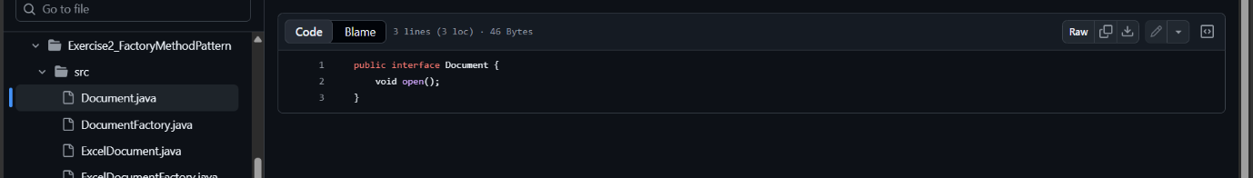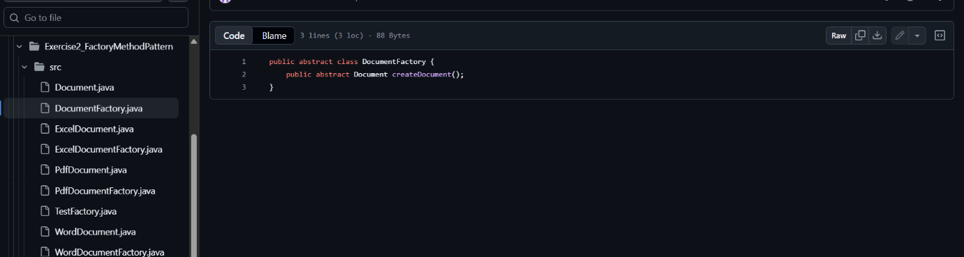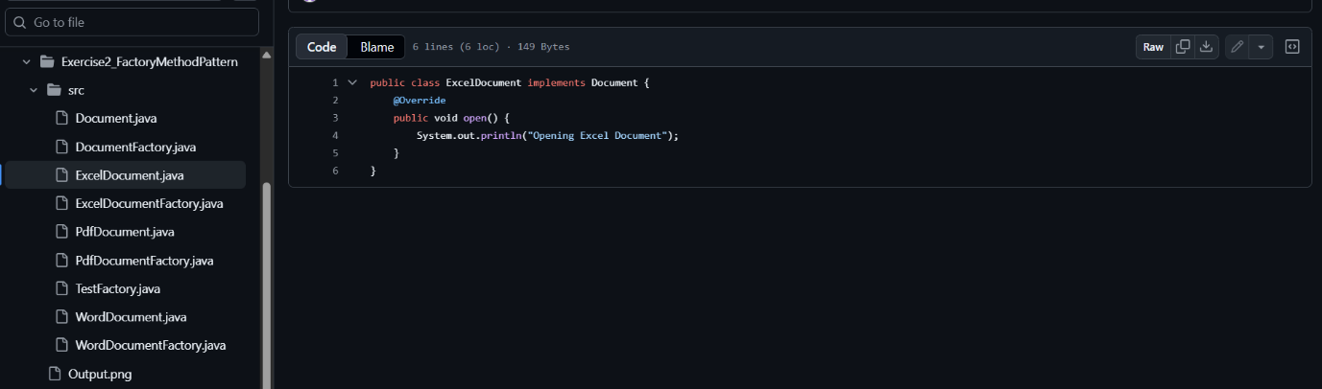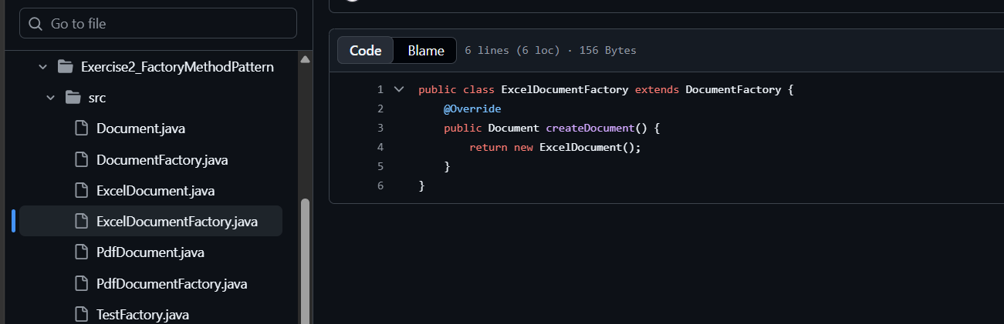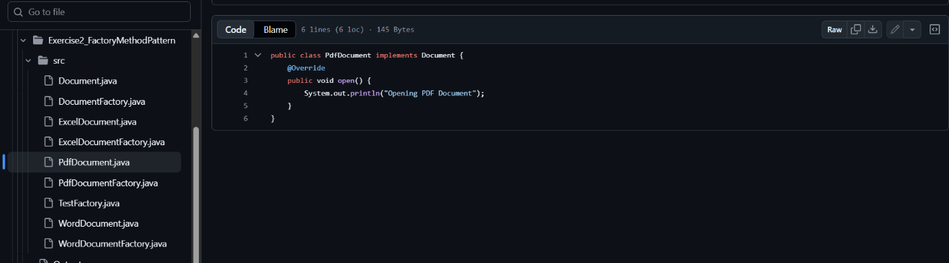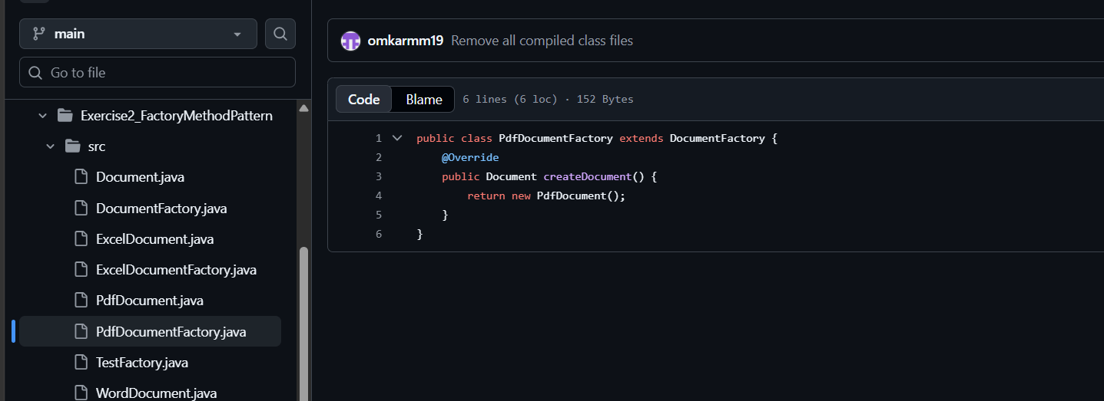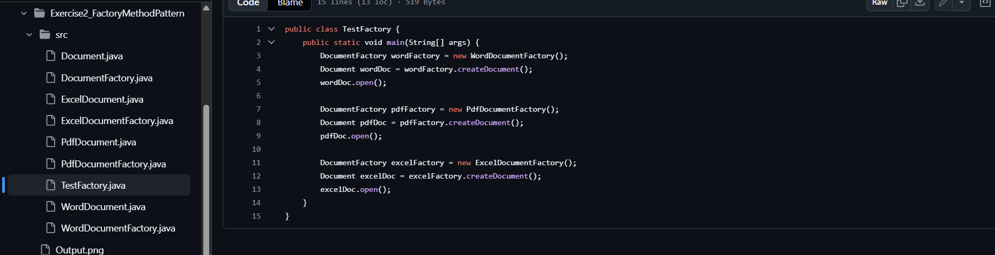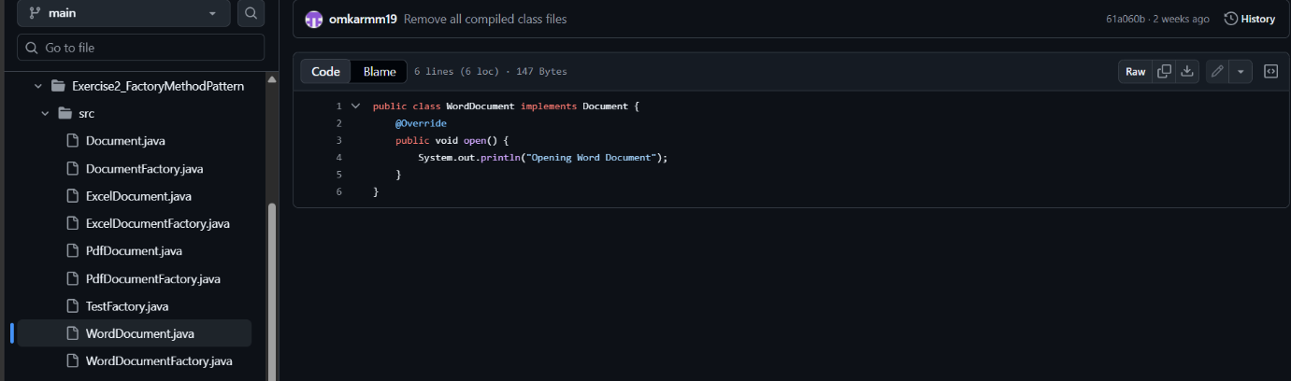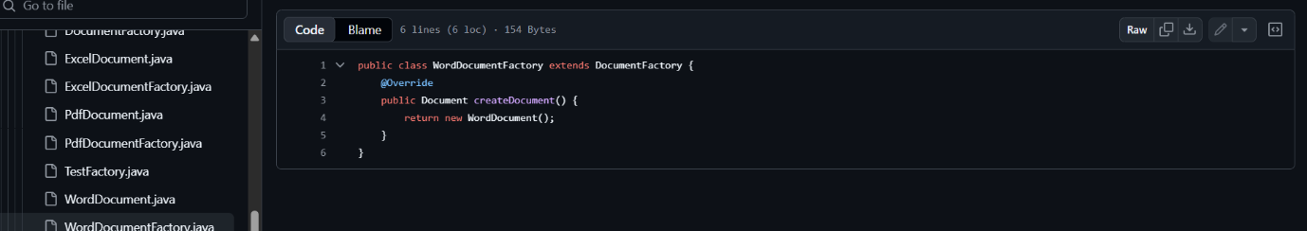

Output
Opening Word Document...
Opening PDF Document...
Opening Excel Document...

Class Diagram
Document
▲
--------------------------
| | |
WordDocument PdfDocument ExcelDocument
▲
createDocument()
|
DocumentFactory
▲
--------------------------------
| | |
WordFactory PdfFactory ExcelFactory

Why Factory Method?
Instead of writing:
Document doc = new WordDocument();
we use:
DocumentFactory factory = new WordFactory();
Document doc = factory.createDocument();
This:
- Hides object creation details.
- Makes the code easier to extend (e.g., adding a PowerPointDocument only requires a new document class and factory).
- Follows the Open/Closed Principle.

Objective
Develop a search function for an e-commerce platform to find products by their ID or name using:
- Linear Search
- Binary Search
Then compare their performance.

Project Structure
EcommerceSearch/
│
├── Product.java
├── SearchOperations.java
└── Main.java

Step 1: Create the Product Class
Product.java
public class Product {
int productId;
String productName;
String category;
public Product(int productId, String productName, String category) {
this.productId = productId;
this.productName = productName;
this.category = category;
}
@Override
public String toString() {
return "Product ID: " + productId +
", Name: " + productName +
", Category: " + category;
}
}

Step 2: Create SearchOperations.java
public class SearchOperations {
// Linear Search
public static Product linearSearch(Product[] products, int id) {
for (Product product : products) {
if (product.productId == id) {
return product;
}
}
return null;
}
// Binary Search
public static Product binarySearch(Product[] products, int id) {
int left = 0;
int right = products.length - 1;
while (left <= right) {
int mid = (left + right) / 2;
if (products[mid].productId == id)
return products[mid];
if (products[mid].productId < id)
left = mid + 1;
else
right = mid - 1;
}
return null;
}
}
Note: Binary Search requires the array to be sorted by productId.

Step 3: Create Main.java
public class Main {
public static void main(String[] args) {
Product[] products = {
new Product(101, "Laptop", "Electronics"),
new Product(102, "Phone", "Electronics"),
new Product(103, "Shoes", "Fashion"),
new Product(104, "Watch", "Accessories"),
new Product(105, "Book", "Education")
};
System.out.println("Linear Search:");
Product p1 = SearchOperations.linearSearch(products, 104);
if (p1 != null)
System.out.println(p1);
else
System.out.println("Product not found");
System.out.println();
System.out.println("Binary Search:");
Product p2 = SearchOperations.binarySearch(products, 104);
if (p2 != null)
System.out.println(p2);
else
System.out.println("Product not found");
}
}

Output
Linear Search:
Product ID: 104, Name: Watch, Category: Accessories
Binary Search:
Product ID: 104, Name: Watch, Category: Accessories

Time Complexity
Algorithm | Best Case | Average Case | Worst Case
Linear Search | O(1) | O(n) | O(n)
Binary Search | O(1) | O(log n) | O(log n)

Why is Binary Search Faster?
- Linear Search checks each product one by one.
- Binary Search repeatedly divides the search space in half, making it much faster for large, sorted datasets.
For example, if there are:
- 10 products → Linear Search may check all 10.
- 1,000,000 products → Binary Search needs only about 20 comparisons.

Interview Questions
Q1. When should you use Linear Search?
- When the data is unsorted or the dataset is small.
Q2. When should you use Binary Search?
- When the data is sorted and fast searching is required.
Q3. Can Binary Search work on an unsorted array?
- No. The array must be sorted before performing Binary Search.
Objective
Predict the future value of an investment using recursion.
Formula
$$\text{Future Value}=\text{Present Value}×(1+\text{Growth Rate})^{n}$$
Instead of using Math.pow(), implement the calculation recursively.

Project Structure
FinancialForecasting/
│
├── FinancialForecast.java
└── Main.java

Step 1: Create FinancialForecast.java
public class FinancialForecast {
// Recursive method to calculate future value
public static double futureValue(double presentValue, double growthRate, int years) {
// Base case
if (years == 0) {
return presentValue;
}
// Recursive case
return (1 + growthRate) * futureValue(presentValue, growthRate, years - 1);
}
}

Step 2: Create Main.java
public class Main {
public static void main(String[] args) {
double presentValue = 10000;
double growthRate = 0.10; // 10%
int years = 5;
double futureValue = FinancialForecast.futureValue(
presentValue,
growthRate,
years);
System.out.printf("Future Value after %d years = %.2f",
years, futureValue);
}
}

Output
Future Value after 5 years = 16105.10

How Recursion Works
For:
- Present Value = 10000
- Growth Rate = 10%
- Years = 5
The recursive calls happen like this:
futureValue(10000,0.10,5)
=1.10 × futureValue(10000,0.10,4)
=1.10 × 1.10 × futureValue(...,3)
=1.10 × 1.10 × 1.10 × futureValue(...,2)
=1.10 × 1.10 × 1.10 × 1.10 × futureValue(...,1)
=1.10 × 1.10 × 1.10 × 1.10 × 1.10 × futureValue(...,0)
=1.10 × 1.10 × 1.10 × 1.10 × 1.10 × 10000
Result:
16105.10

Time Complexity
- Time Complexity: O(n)
- Space Complexity: O(n) (due to the recursion call stack)

Interview Questions
Q1. Why use recursion here?
- To repeatedly apply the growth factor until the number of years reaches 0.
Q2. What is the base case?
- years == 0, which returns the present value.
Q3. Can this be implemented iteratively?
- Yes. A loop would achieve the same result and would use O(1) extra space.
Objective
Write a PL/SQL program that demonstrates the use of IF-ELSE, LOOPS, and CONTROL STRUCTURES.
A common Cognizant FSE exercise is to calculate a customer's discount based on their balance.

Step 1: Create Customer Table
CREATE TABLE Customers (
CustomerID NUMBER PRIMARY KEY,
CustomerName VARCHAR2(50),
Balance NUMBER
);

Step 2: Insert Sample Data
INSERT INTO Customers VALUES (101, 'Rahul', 12000);
INSERT INTO Customers VALUES (102, 'Aman', 8000);
INSERT INTO Customers VALUES (103, 'Priya', 15000);
COMMIT;

Step 3: PL/SQL Program (Control Structures)
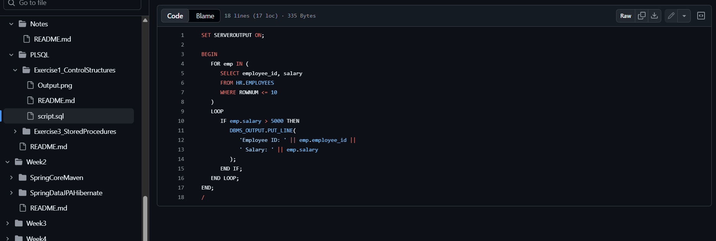
SET SERVEROUTPUT ON;
DECLARE
v_balance Customers.Balance%TYPE;
v_discount NUMBER;
BEGIN
FOR rec IN (SELECT CustomerID, CustomerName, Balance FROM Customers)
LOOP
v_balance := rec.Balance;
IF v_balance >= 10000 THEN
v_discount := v_balance * 0.10;
ELSE
v_discount := v_balance * 0.05;
END IF;
DBMS_OUTPUT.PUT_LINE(
'Customer ID: ' || rec.CustomerID ||
', Name: ' || rec.CustomerName ||
', Discount: ' || v_discount
);
END LOOP;
END;
/

Output
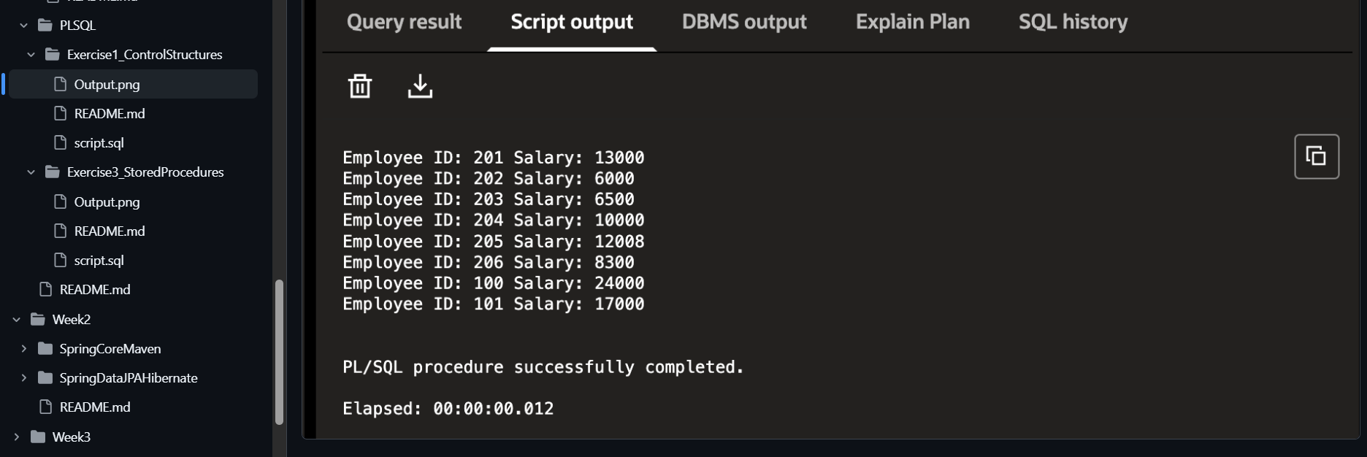
Customer ID: 101, Name: Rahul, Discount: 1200
Customer ID: 102, Name: Aman, Discount: 400
Customer ID: 103, Name: Priya, Discount: 1500

Concepts Used
- DECLARE – Declares variables.
- FOR LOOP – Iterates through each row in the table.
- IF...ELSE – Applies different discount rates based on balance.
- DBMS_OUTPUT.PUT_LINE – Prints output to the console.

Exercise 3: Stored Procedures
Objective
Create a stored procedure that updates a customer's balance based on their Customer ID.
Step 1: Create the Customer Table
CREATE TABLE Customers (
CustomerID NUMBER PRIMARY KEY,
CustomerName VARCHAR2(50),
Balance NUMBER
);

Step 2: Insert Sample Records
INSERT INTO Customers VALUES (101, 'Rahul', 10000);
INSERT INTO Customers VALUES (102, 'Aman', 8000);
INSERT INTO Customers VALUES (103, 'Priya', 15000);
COMMIT;

Step 3: Create the Stored Procedure
CREATE OR REPLACE PROCEDURE UpdateBalance(
p_CustomerID IN NUMBER,
p_Amount IN NUMBER
)
IS
BEGIN
UPDATE Customers
SET Balance = Balance + p_Amount
WHERE CustomerID = p_CustomerID;
COMMIT;
DBMS_OUTPUT.PUT_LINE('Balance Updated Successfully.');
END;
/

Step 4: Execute the Procedure
SET SERVEROUTPUT ON;
BEGIN
UpdateBalance(102, 2000);
END;
/

Step 5: Verify the Result
SELECT * FROM Customers;
Output
CustomerID | CustomerName | Balance
101 | Rahul | 10000
102 | Aman | 10000
103 | Priya | 15000

Explanation
The stored procedure accepts two input parameters:
- p_CustomerID → Customer whose balance needs to be updated.
- p_Amount → Amount to be added.
It then executes:
UPDATE Customers
SET Balance = Balance + p_Amount
WHERE CustomerID = p_CustomerID;
Finally, it commits the transaction and prints a success message.

